Out of Sight: The Development of a Surreal VR Horror Experience

A commentary on the Surreal Horror Audio/Visual VR experience developed by Anthony Woodward in collaboration with Harri Bettsworth

Anthony Woodward

**Abstract.** This commentary considers virtual reality (VR) to be a tool for engaging users as much as possible into the experience being put in-front of them. Never has a technology gone this far to immerse the human senses into an experience. Out of Sight is a horror experience using Virtual Reality to engage the user. VR principles have been used throughout development for interaction to help the user feel present in the world, whilst the head-mounted display is used to encompass the user’s vision within the virtual world. Along-side the VR hardware, immersive spatialised audio composed and implemented by Harri Bettsworth is a focus feature of Out of Sight. The audio has two goals, to drive the story, narrative and feeling of the experience, whilst also being spatialised in 3D space to involve complex human hearing in the experience.

**Keywords**. Virtual Reality (VR) • Immersion • Engagement • Surreal Horror • *Oculus Quest 2* • PCVR

[Out of Sight – Walkthrough Video](https://www.youtube.com/watch?v=eT0Zhjn9aa0)

https://www.youtube.com/watch?v=eT0Zhjn9aa0

**Acknowledgments**:

I would like to thank everyone who supported me throughout my Creative Technologies MSc studies, and throughout the development of my major project and dissertation.

Firstly, I would like to thank all the academic staff from the Institute of Creative Technologies at De Montfort University. I would especially like to thank Prof Sophy Smith for the guidance I received throughout and before my major project.

Finally, I would like to thank my family for supporting me throughout my 4 years away from home, as this support got me to where I am today.

Contents

Introduction 6

Define 6

Design 8

The Story 9

Development 14

Audio Development 16

VR Development 20

Experience Development 23

Conclusion 25

References 27

Appendices 29

Table of Figures

Figure 1: Robert Plutchik’s Wheel of Emotions (Plutchik, 1988)8

Figure 2: The front door and the father’s office 9

Figure 3: Entering the basement and entering the lucid level 10

Figure 4: The Motel Room10

Figure 5: The Maze with clue scenes overlayed 11

Figure 6: Key through the motel room window11

Figure 7: Waking up in the basement and the cot room 12

Figure 8: The extra clues at the end, and the exit doors12

Figure 9: Interactive Narrative Map 13

Figure 10: The Oculus Quest 2 used for development 15

Figure 11: Steam Audio Plugin's spatializer used in the FMOD project 17

Figure 12: FMOD, music track minimalist 1. Example of parameters 19

Figure 13: A top-down diagram of the audio parameter triggers in the maze section of level 'Father'20

Figure 14: Image of the teleportation system in Out of Sight21

Figure 15: A VR interactable door with keyhole, Hinge and Doorhandlevisible22

Table of Appendices

Appendix A: BuildLoader.cs29

Appendix B: SceneLoader.cs30

Appendix C: Singleton.cs33

Appendix D: XRInteractionManagerExposed.cs34

Appendix E: UnregisterInteractor.cs35

Appendix F: TeleportAreaFade.cs36

Appendix G: SpawnPoint.cs38

Appendix H: ResetTrackedPoseDriver.cs40

Appendix I: GameData.cs41

Appendix J: Screen Fader42

Appendix K: EndManager.cs47

Appendix L: ResetPosition.cs48

Appendix M: TextScroller.cs49

Appendix N: PictureFade.cs51

Appendix O: OnTrigger.cs52

Appendix P: HouseSetup.cs53

Appendix Q: DoorHandler.cs55

Appendix R: AddForce.cs56

Appendix S: Bloody Cot Adaptive FMOD Piece57

Appendix T: Minimalist 1 Adaptive FMOD Piece58

Appendix U: Minimalist 2 Adaptive FMOD Piece59

Appendix V: Maze Adaptive FMOD Piece60

Appendix W: Initial Story board61

# Introduction

Does Virtual Reality impact user engagement? In other words, does the use of spatialised audio and Virtual Reality hardware such as HMDs and controllers have an impact on how immersed the user gets into the experience, and what are the drawbacks? Immersion is a concept familiar to many mediums, but it is mostly used for software when talking about video games and Virtual Reality. According to Brown et al. (2004) Virtual Reality research points to an interesting perspective on immersion where “a person’s cognitive and perceptual systems are tricked into they are believing they are somewhere other than their physical location”. Usually, immersing yourself in a video game means the user shuts the world out, however Virtual Reality can shut the real world out for you. Out of Sight attempts to use this feature of Virtual Reality to ground the user into the surreal experience.

Despite virtual reality being great for immersion, it is still a new platform. Developing for VR headsets can be a challenge, and much of the development of Out of Sight was focused on the VR systems. It could be argued that without the need to develop for virtual reality, other features could be developed that immerse the user narratively due to the significantly reduced development time. Virtual Reality is rapidly increasing its user-base, and as the technology sells more, the development tools will improve. Hayden (2021) reported that 3 million Oculus Quest 2 units sold in the fourth quarter of 2020 alone, and the Quest 2 has already sold more than its predecessors combined. However, VR development at its current state still presents many challenges that traditional game development would not.

# Define

Out of Sight is a surreal horror experience with many inspirations. Horror VR games such as Resident Evil 7 and Half-life: Alyx were perfect examples of how virtual reality experiences should be developed, and how modern surreal horror can be used in video games. Half-Life: ALYX by Valve is a game developed almost as a VR tech demo. The game shows the world how a Virtual Reality game should be made, with revolutionary leaps made in locomotion, interaction, and virtual reality game design. There is a huge difference between a game made for VR and a game converted to VR. As Feltham (2020) states in his review of Half-Life: Alyx, “Comfort is a big concern for Valve, and it shows. Alyx is littered with different options to accommodate as many people as possible.”. Feltham states this in response to Valves commitment to creating a great VR experience by implementing multiple high-quality features for movement for the user to select which is best for them. Designing a game with these features at the centre creates a fluid and flow like experience, opposed to the jarring experience caused by virtual reality functionality being jammed in at the end. Half-Life: Alyx is the opposite to Resident Evil 7 VR, as this game was developed without VR in mind, with a VR port later being released. As Hills-Duty (2018) explained in her review, the ability to peak around corners adds to the immersion, however the game is controlled by a normal PlayStation controller, which isn’t the best way of interacting with the virtual world. It was important for Out of Sight to take full advantage of the hardware required to play it. Like Half Life: Alyx, Out of Sight is designed and made for VR and VR only, so the world and the interaction had to be as close to realism as possible with current technology.

A big portion of the inspiration for Out of Sight came from Harri Bettsworths composition inspirations. Media such as The Shining by Stanley Kubrick (1980), Eraserhead by David Lynch (1977), and Silent Hill 2 (Tsuboyama, 2001) directly inspired the total design of the experience in both the experience design and sound design. Silent Hill is a video game series that directly inspired the visual experience, as the demo P.T. (initialism for "playable teaser") (Kojima, 2014), from an unreleased Silent Hill game, was a large inspiration for how Out of Sight should look and feel. P.T. is set in an abandon house with a paranormal and surreal atmosphere. As the player progresses, the environment and storyline changes around them. This directly influenced some of the multiple-choice and branching narrative design in our experience, that enables user exploration to change how the experience reacts to them. In terms of creating an experience with an adaptive soundtrack telling the narrative, two games come to mind. The games Outer Wilds (Beachum, 2019) and Hellblade: Senua’s Sacrifice (Antoniades, 2017) use advanced audio as a part of the narrative, with Outer Wilds incorporating its soundtrack into the game world to tell a grand story of the people who live there, and Senua’s Sacrifice uses brilliant binaural audio and spatialised sound to portray the experience of battling with psychosis.

# Design

Figure 1 Robert Plutchik’s Wheel of Emotions (Plutchik, 1988)

Out of Sight does borrow from its inspirations, but it also very much does its own thing. The experience was about creating an effective VR audio visual experience, with a focus on using audio in a virtual space to cause emotion in the user, such as fear and discomfort. Using Robert Plutchik’s Wheel of Emotions (Plutchik, 1988) as a guide (*fig. 1*), a model that puts opposing emotions opposite from one another, Out of Sight is designed to cause feelings of awe, apprehension, fear, distraction and surprise. The focus of Out of Sight isn’t to cause pure terror in the user, but it is to distract and immerse them with a surprisingly adaptive experience that unsettles the player. Apprehension and fear slow the experience, by allowing players to hold back and lean around corners. If the user reacts to the experience as designed, then the fear and apprehension will immerse them further as this will open more of the adaptive audio and narrative experience, with exploration rewarding the player with a surprising and surreal underlying story.

Out of Sight uses perspective and setting to aid the audio focused narrative. Without the audio, Out of Sight would miss the fear and apprehension emotions targeted, however the audio alone can create this feeling. The visuals, interaction and virtual reality exploration aspect of Out of Sight offers the distraction and immersion to the player to set them into the experience, with the branching narrative, and narrative-telling adaptive and environmental audio fostering surprise and shock in the player. The relationship between VR and immersion directly benefitted the narrative due to the added feeling of being in the scenario instead of just playing a game. It is due to this that Out of Sight is referred to as a Surreal Horror VR Experience throughout all documentation and not a Horror game, as the focus of Out of Sight is to experience the narrative, with interaction being a feature to increase engagement with the narrative.

## The Story

The development of Out of Sight began with a story board (See Appendix W) which created a baseline for what we wanted the narrative to be. The narrative is complicated in Out of Sight as it is never explicitly told the audience member and is instead uncovered by the audience members interaction, attention to detail and exploration. We based the theme of the story around a Police officer reporting to a domestic dispute call with previous child safety warnings on the property. The location of the experience is fictitious and an amalgamation of British and American households, families and police systems. A lot of the themes we decided to touch on with Out of Sight are disturbing, with topics of abuse, child mortality and possession, which were all centred around the Catholic view of sin.

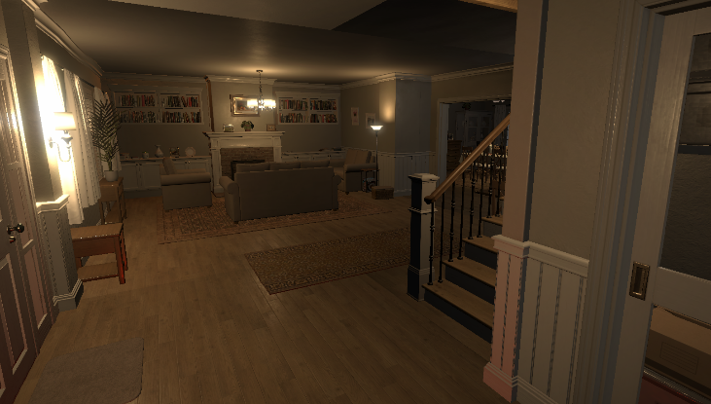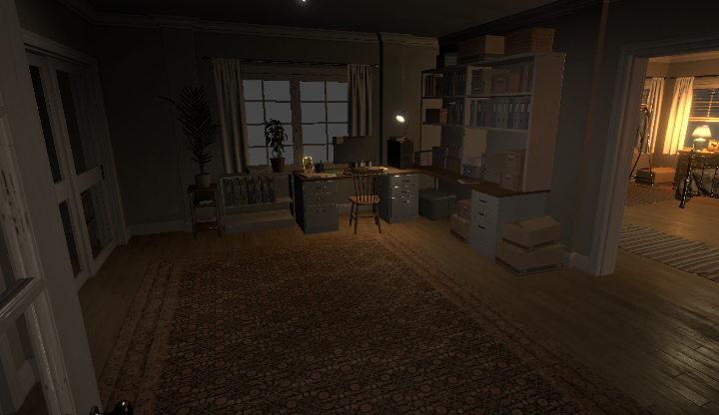

Figure 2 The front door and the father’s office

The experience begins as the audience member rides to the location in their police car, with dialogue presented outside the windscreen and through the police radio to explain the job. The player then loads into a silent and eery house. The player is urged to explore by an adaptive minimalistic soundtrack, leading them to a key in the father’s office (*fig. 2)*. This key opens the door to the basement where the player can interact with a fuse box, knocking out the character and sending them to a liminal dream space (*fig. 3)*.

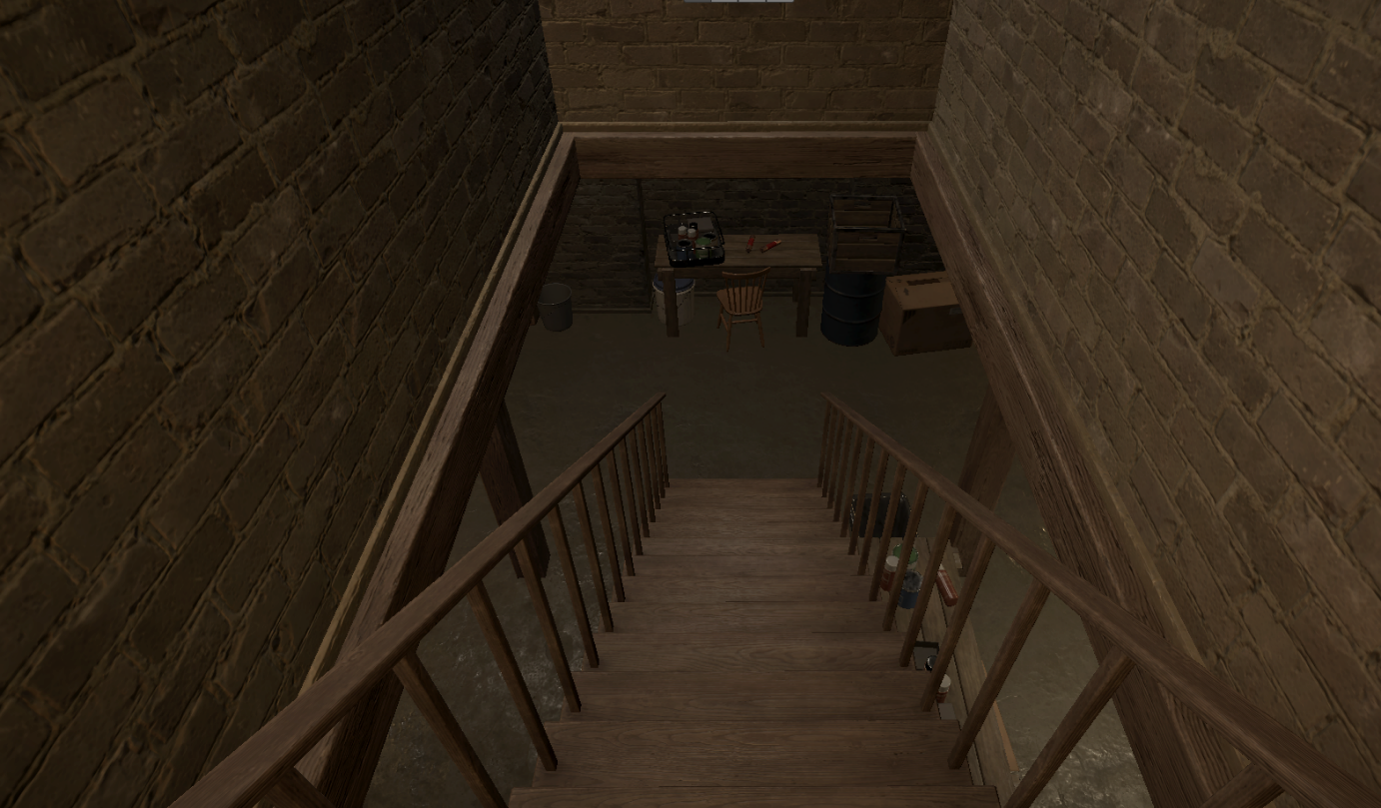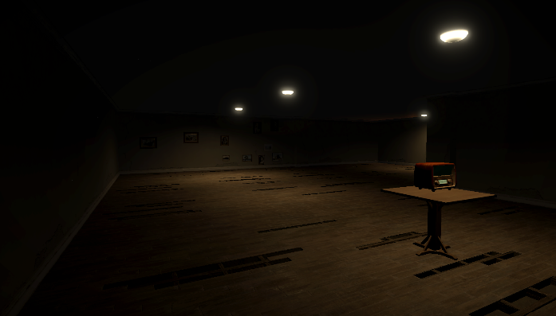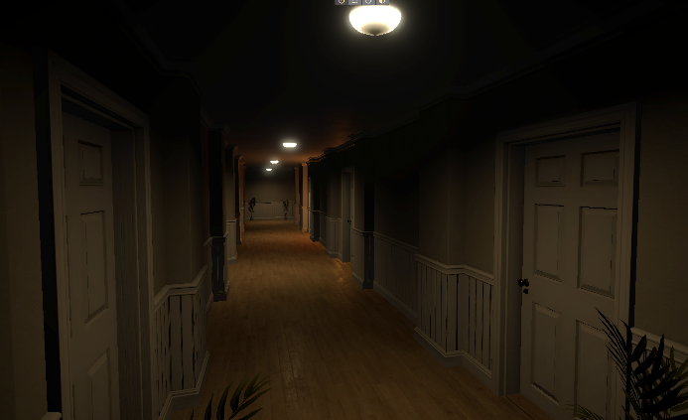

Figure 3 Entering the basement and entering the lucid level

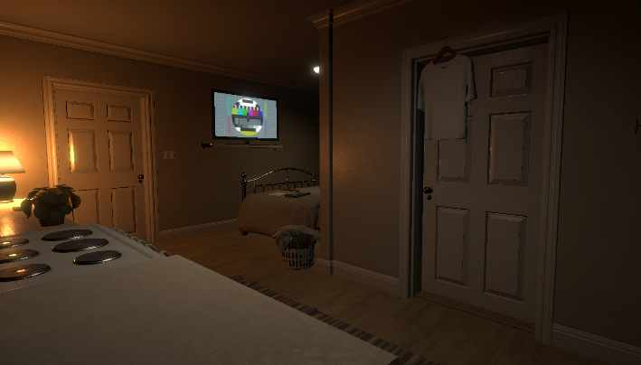Whilst exploring through the lucid level, the player can get lost through mazes of hallways inspired by the Liminal Spaces aesthetic. The player finds themselves in a motel room (*fig. 4*), with the father being heard begging for forgiveness behind a doorway. This scene is set to look like the father has run away, and clues throughout the level suggest that the fathers’ sin was causing his wife to miscarry their child through abuse.

Figure 4 The Motel Room

After this strong narrative section, the player enters a maze of walls with clues and adaptive audio guiding them through the level and giving the player clue to the fathers’ emotional state by the scenes set throughout the maze (*fig. 5)*.

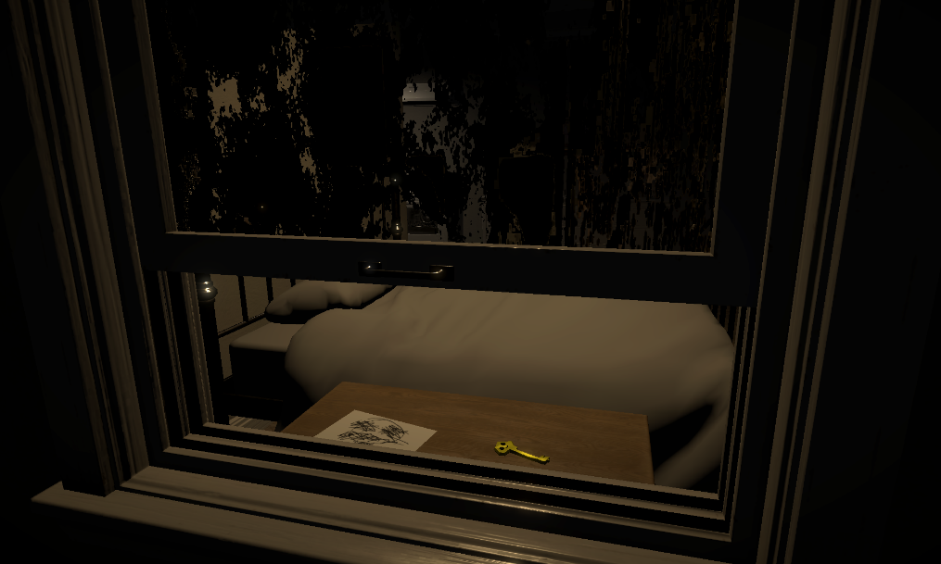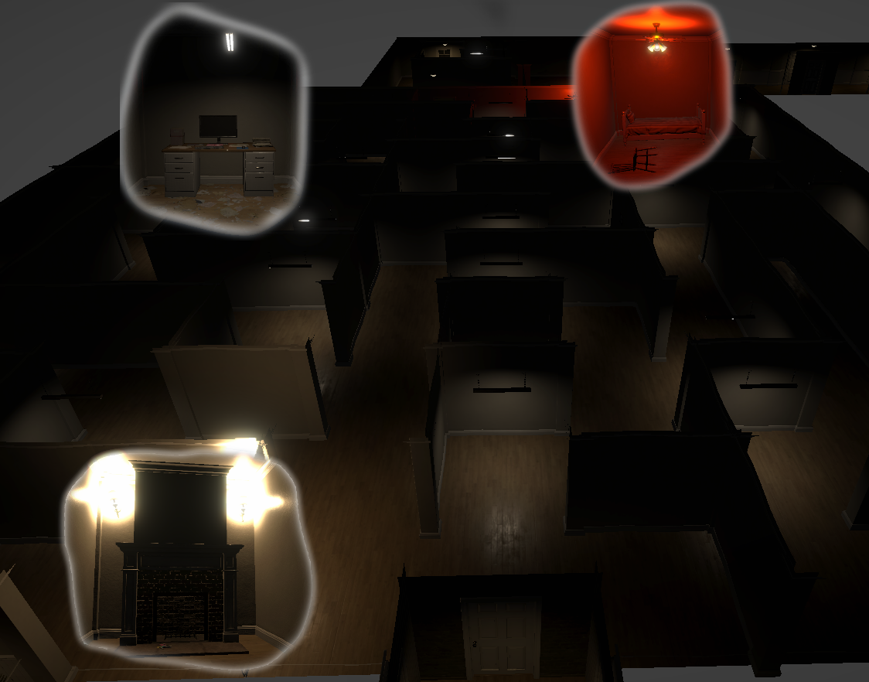Once the maze is escaped from, the player finds themselves on the outside of the previous motel room, with the father’s audio seemingly more demonic and the room more trashed than it was before. Leaning through a gap in the window gives the player access to a key (*fig. 6*) that leads them through the door at the end of a long hallway. This hallway has screaming coming from behind the doors, until suddenly the screen cuts and the player awakes in the basement again, although things have changed.

Figure 6 Key through the motel room window

Figure 5 The Maze with clue scenes overlayed

Once the player is back in the house, they can hear crying from upstairs. Investigating this will lead to the cot room, where the cot rocks itself and the children’s drawings of a demon flash in the air (fig. 7). This is paired with the mother whimpering a lullaby coming from the empty cot, this is to tell the narrative of the mother’s intense grief from what has happened to her.

Figure 7 Waking up in the basement and the cot room

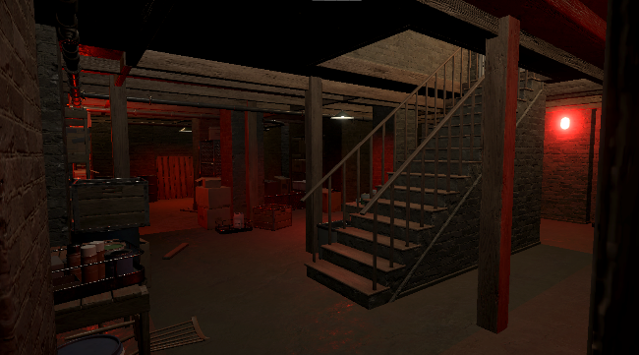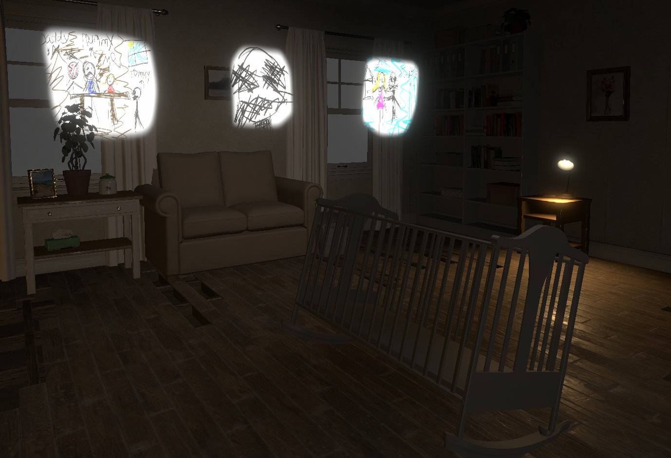

After the mother section, the player can leave the house and get an ending of the game that shows that there was nothing to add to the police report, however if the player continues to explore the house, they can be led to clues that show that the little girl who lives at the address is friends with a demonic character (*fig. 8)*. Said demon will eventually get angered at your presence, throwing toys at you and screaming for the player to ‘get out’. When the player leaves after these events, the lord’s prayer is recited to them and the game ends with a recommendation that the police officer protagonist should receive a psychological review due to the nature of the events that they reported at the address.

Figure 8 The extra clues at the end, and the exit doors

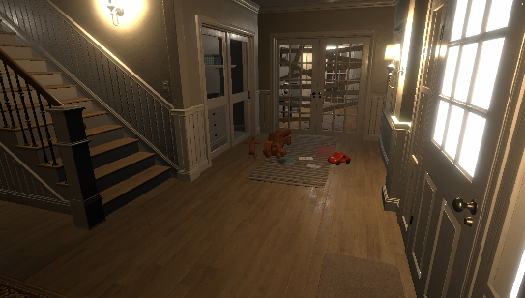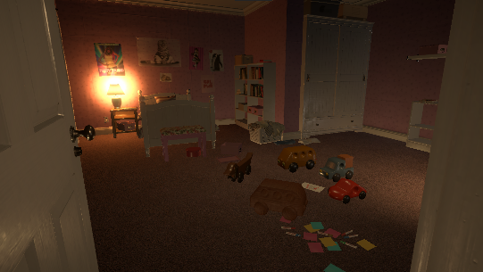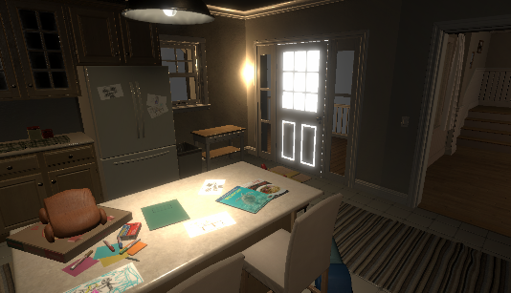

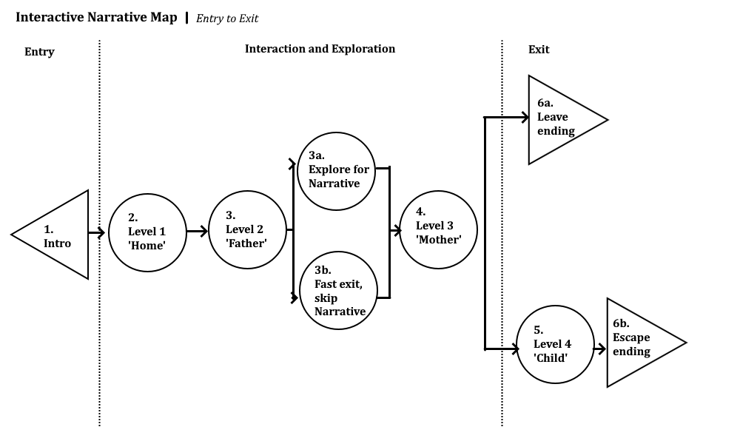As mentioned, the story of Out of Sight is told through user exploration. This is inspired by many horror games, but especially the forementioned ‘P.T.’. In this demo experience, the story may not be obvious on the first play through, or ever. It is up to the player to explore the environments to gather as much information about the narrative as possible. In the Interactive Narrative Map below (*fig. 9*), the options to explore for narrative are displayed. In the second level of Out of Sight ‘the father’, multiple dialogue lines and set pieces are placed around a maze of hallways. The more of the environment explored, the more clues to the narrative revealed. Options like not leaving at the end Out of Sight open up the option to continue exploring and doing so can lead to extra narrative experiences and a different ending to the experience with a different conclusion.

Figure 9 Interactive Narrative Map

A branching narrative or modular ending system in a game or virtual experience brings the player into the role of the creator or author, as the actions and interaction from the player drives the narrative in a certain direction. Lindley (2005) states that this can encourage an Immersionist state of play, which is Lindley describes as:

“The state of total player identification with the character, representing the players being within the game world”

Out of Sight isn’t the first 3d experience or game to include diverging narratives and multiple endings, as this is commonplace in modern video games and interactive entertainment, with Resident Evil 7 and The Outer Wilds both being examples of games that do this. Modular endings and branching storylines increase an experiences replay-ability, as each playthrough could be slightly different. As Out of Sight is designed to keep the narrative partly hidden from the player, encouraging a second playthrough will enable players who didn’t understand the entire storyline to give it another shot.

The branching narrative adds a level to the explicit narrative of the experience that mediums such as cinema can’t replicate. The focus on the narrative for Out of Sight is due to it being an explicit narrative as opposed to a video games implicit narrative. Pittman (2015) describes the difference between implicit and explicit narratives is that an implicit narrative is a story for the use of gameplay, for instance, in Super Mario, the story is in-place to explain the gameplay. Whereas explicit narrative is a genuine story, which the experience exists to tell. For-instance in Out of Sight, the experience features such as exploration and interaction are in-place to benefit the explicit narrative.

# Development

The beginning concept of Out of Sight was to combine my VR development experience with Harri’s surreal horror composition to make a Horror Game. This pushed me to work with Unity to develop the VR experience as it’s what I am familiar with. The Unity development started slow due to the complexity of VR development. I chose to use Unity version 2021.1.22f1 so I could use the most up-to date version of the XR Interaction Toolkit, a package by Unity Technologies to streamline VR development. To begin developing, many of our questions had to be answered, such as what audio middleware to use, whether to use premade assets or to create everything ourselves and what VR hardware to use. With the middleware we settled on using FMOD over WWise software. According to WWise (Audiokinetic Inc., 2021), it is the most advanced and feature rich audio solution for games, however both me and Harri had experience with FMOD and we knew it could do what we wanted so we went with FMOD as our audio engine. In terms of what hardware to use, the best headset we had available was the Oculus Quest 2 and given that Hayden (2021) has explained the popularity of that headset trumps all competition, it was the right choice.

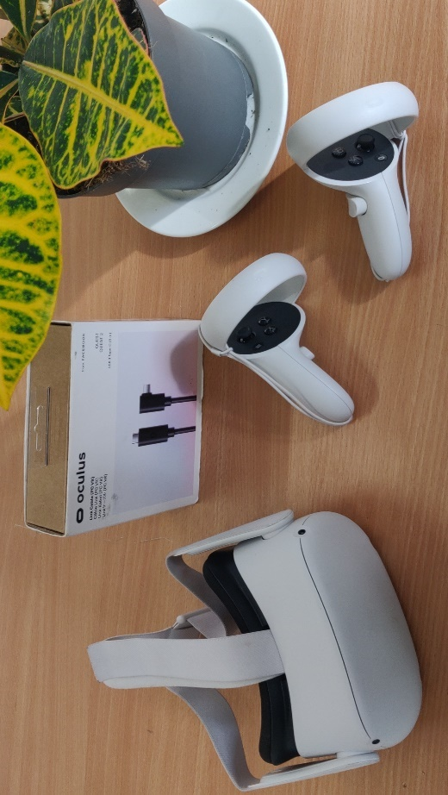However, the question on whether we should use premade assets was difficult. For Harri, it didn’t make sense for premade assets to be purchased for her work, but for the 3D experience development I decided it would be worth the time saved. Due to this, three different assets were purchased. These assets entered my own personal collection, which is great for future use, however in this project, acquiring the Kids Wooden Toy pack, a Baby Cot and the full Atmospheric house pack from the Unity Asset Store and CG Trader online meant that I didn’t need to attempt any 3D modelling myself. Choosing not to purchase these assets would have delayed the project significantly, and the quality of the assets used would have dipped. These assets enabled both Harri and I to focus on what we are good at, improving the overall quality of the project to a level we couldn’t have done without purchasing said assets.

Figure 10 The Oculus Quest 2 used for development

## Audio Development

FMOD Studio was used as the middleware between Harri’s work and the actual experience. FMOD enabled Harri to create adaptive audio pieces and then the FMOD audio events could be spatialized in 3D virtual space. Using the FMOD Unity plugin allowed those pieces to be directly used in engine without much input needed. FMOD was used with the Steam Audio Plugin, an audio spatialization engine for FMOD, Unity and other engines. Steam Audio gave us two main features, HRTF (Head-Related Transfer Function) and spatialization, that once Harri and I configured in FMOD, could easily be implemented into the Unity project.

HRTF Is used to mimic the auditory spatial localization in humans. Berger et al (2018) explains how Spatial localisation is “a combination of interaural time differences, interaural level differences, as well as spectral cues provided by the geometry of the ear”. Berger et al found that Head Related Transfer Functions should be used to simulate natural acoustic perception in VR in either an individualized or generic manner. Individualized HRTFs are modelled on a per user basis to get a very accurate representation of an acoustic environment. Of course, a custom HRTF for each user in a VR experience would be a difficult feature to implement as every user would have to be modelled. For Out of Sight, a generic Nearest-Neighbour HRTF function provided by Steam audio was used. Nearest-Neighbour relates to how the HRTF is calculated in engine, with a more accurate Bilinear Interpolation option being available, but too performance intensive for this application (Steam Audio, 2017). Bilinear Interpolation would have been the choice for Out of Sight if there was more movement in the audio sources, as Nearest-Neighbours HRTF is noticeable when in movement. Steam Audio captured their HRTF using a dummy head. This technique uses in-ear microphones in the dummies ear canal, whilst speakers in defined locations around the room play a specific tone for the microphones to capture. The audio the microphones capture will have time, frequency and volume variations due to the sound traveling around the head. The data captured here is what informs the HRTF to replicate said variations in a virtual environment through headphones.

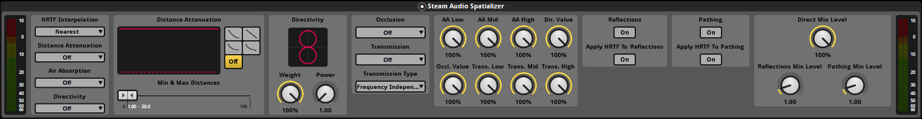

Figure 11 Steam Audio Plugin's spatializer used in the FMOD project

Alongside HRTF, Steam Audio provided us with a suite of useful tools and algorithms to simulate realistic audio in a virtual environment. Out of Sight uses Distance Attenuation, Air Absorption, Directivity and Occlusion all provided by the plugin. Simply put, Distance Attenuation decides the volume of a sound source based on the distance between the source and the listener, Air Absorption specifies how frequency-dependent distance-based air absorption is calculated and applied to the sound, Directivity specifies the directionality of the sound emitting from the source, and Occlusion attenuates the sound when a sound source is occluded behind an object (Steam Audio 2021). Steam Audio had much more functionality, such as audio reflections and transmission modelling, however due to the platform being Virtual Reality, performance of the experience had to be prioritised, so complex features were reduced when not necessary. These features were configured easily using the FMOD Steam Audio Spatializer plugin (*fig. 11*) and then related steam audio components were implemented to the sound sources in Unity. This implementation was simple for me to do in engine, however it took a long time to fine tune and get right.

Using Steam Audio and FMOD was straight forward for me, as installing the plugins into Unity is and following the installation wizard is all that is needed. That isn’t to say that development with these tools was difficulty free. Version control between the FMOD files that both me and Harri had would sometimes be tricky, with progress often being lost due to overwriting changes. This is a problem in software development that is usually corrected with team management tools such as GitHub (2021), which we employed for data management and project security. However, GitHub wasn’t an effective tool for FMOD, especially when the files were switching between Operating Systems. Instead of Git, Harri and I used Microsoft Teams to upload and keep track of files using Microsoft OneDrive. This method wasn’t perfect, but it worked well enough for us to stick with it. Microsoft Teams was a tool used throughout the project for communication, meetings and sharing of documents. Harri and I kept research diaries and a timeline of what we were working on, and all requests were handled through this platform. MS Teams was great for this, as it was one location where all project management and documentation were kept, and where all our text communication was kept, making it very easy to refer to. As Harri didn’t need access to the source files of the project, there was no need for further collaboration tools to be used. FMOD itself caused issues through development. On multiple occasions, the FMOD integration with Unity would stop working, with restarts, reinstalls, and many hours of debugging necessary to continue making progress on the project. It is due to this experience that I would not recommend using an external audio engine with Unity for beginners, as it can add unexpected complications that can be difficult to solve for individuals without software debugging skills and experience. One example of this was half-way through development when the Distance-Attenuation functionality stopped working. This meant all audio could be heard at any distance, which both was unrealistic and sounded awful. The most confusing part about this issue was when it corrected itself without my input a week later. I had created a system to do the distance attenuation manually, but this was eventually discarded due to FMOD self-correcting the bug.

FMOD was worth the challenges in the end. It uses a brilliant parameter system that allows simple triggers to change the adaptive soundtrack with no additional coding. (*fig. 12*) A similar system in Unity alone would be a very complicated system to implement, and FMOD was invaluable for this functionality, even without Steam Audio which can be credited with bringing additional complications to the development. In engine, different events send values to the FMOD audio engine. In Out of Sight, these parameters control volume, occlusion values, and most importantly, the parameters specify what part of an adaptive track should be playing by jumping and fading between looped sections of a single event track. The use of the progress parameter allows the adaptive music to loop and adjust complexity depending on the players progress through the narrative in the experience. Note that many of the transitions allow the progress to back track for instances where less complexity in the audio is necessary, for instance when the player goes the wrong way. This is an example of how the audio was also used to guide the player with a soft touch throughout the experience, as the audio increases with complexity as narrative progression is made. Tempini (2019) describes guiding with a soft touch as a technique of directing players throughout levels without a user interface. The careful use of landmarks and points of interest 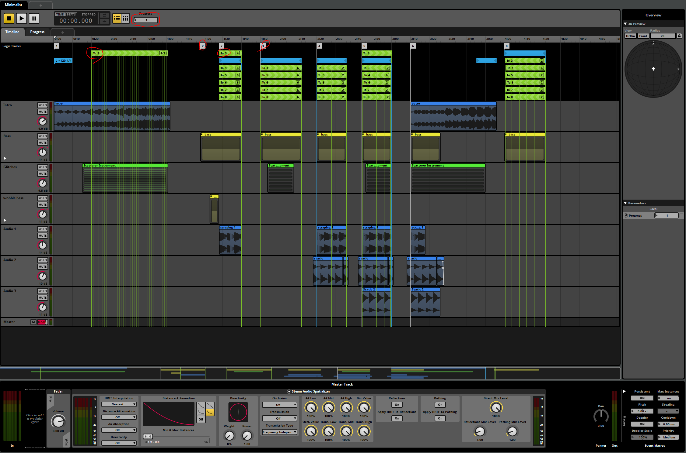can guide a player, and Out of Sight does this in multiple ways.

Figure 12 FMOD, music track minimalist 1. Example of parameters

This method of increasing the complexity to show the player they are making progress is used in the maze section of the father level. Figure 14 shows green boxes that indicate the areas that trigger a change in the parameter, with the red path showing the best route to get through the maze. Not following the set path rewards the player with narrative clues, but the audio still guides the player in the correct direction, so these narrative clues could be missed.

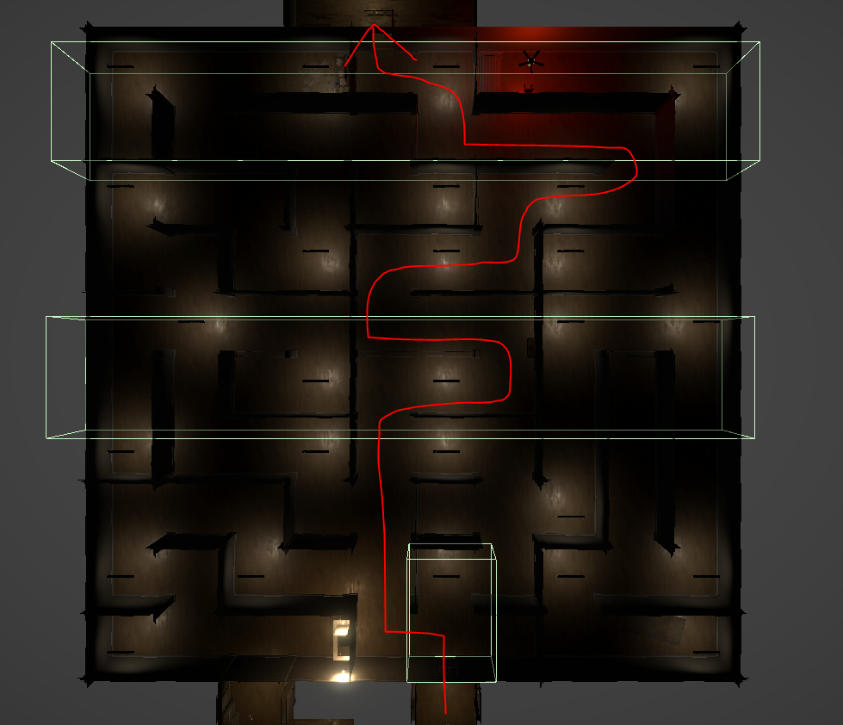

Figure 13 A top-down diagram of the audio parameter triggers in the maze section of level 'Father'

## VR Development

As I wrote earlier, Unity was used for the development process. Unity was an easy choice for me, as it’s a great tool for developing for Virtual Reality. Unity offers several first party and third-party plugins to allow you to develop for almost any virtual reality, augmented reality or mixed reality hardware. As well as this, even if there was a better alternative to use, my 6 years of Unity game development experience made Unity the only choice for this project, as I already knew how to make VR experiences in this engine, my previous projects Void and Unlikely Things being examples of this. My experience didn’t mean the VR development was a walk in the park, and the VR systems took a significant amount of time to get right.

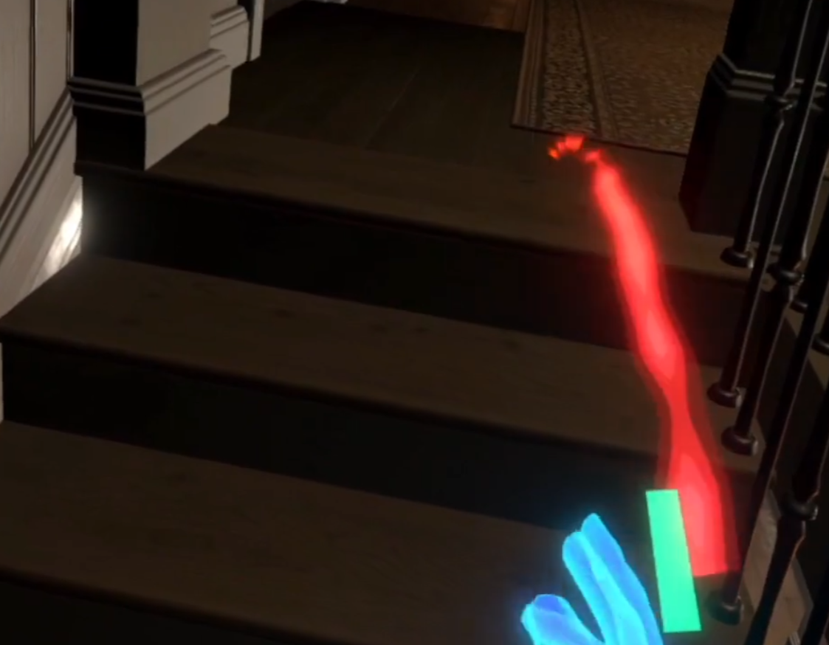The VR development can be split into two parts, the systems, and the experience design. The systems were partly provided via the XR Interaction Toolkit plugin that Unity provides through its package manager. I started with setting up the VR controller to allow a user with a Quest 2 Headset to move around and exist in the virtual environment. A lot of the XR Interaction Toolkit had to be rewritten to work with different input management options, and all the in-built audio systems had to be removed and replaced due to the specific FMOD audio systems that were being used in this project. VR can often make simple things much more complicated, such as switching scenes and levels. This is where I had to create my own VR systems, which took most of the projects development time. These systems enabled the VR controller to stay loaded in the game, and to allow multiple different scenes to load in seamlessly with no lag and no audio cutting. I also adapted the teleportation system provided by Unity to allow the user to move freely around the environment (*fig. 14*), with a fading screen graphical system for teleportation and loading to reduce VR related sickness in users.

Figure 14 Image of teleportation system in Out of Sight

Thankfully, Unity is well documented, but importantly, Unity has a huge community of developers creating online content. This enabled me to search the web for developers that had already solved my issues. Connell (2021) created the YouTube channel ‘VR with Andrew’ that I used a lot in the beginning of development. Andrew’s channel is full of short videos showing how to create VR systems and functionality in Unity using the XR interaction toolkit. Having access to great examples and tutorials on how to implement the features I want in the experience is amazing. Unfortunately, with software version differences these tutorials often didn’t work as planned, however they are great for starting with VR development. Accessing sources online with other people’s code is commonplace in programming, with sites like GitHub and Stack Overflow almost dedicated to sharing code, and this practice was commonplace during this project due to the extensive amount of content produced for the technology I was using. This aided development as I could get myself unstuck without having to ask for help from other developers.

The VR functionality of Out of Sight runs on OpenXR, an SDK for creating virtual environments that run on VR hardware. The original plan for the experience was to develop for the Quest 2 directly using the Oculus SDK. OpenXR also works on the Quest 2 so the development shifted focus to getting the experience to run natively on PC through OpenXR and then later porting the experience to various standalone platforms and digital stores. I clearly saw into the future when making this decision, as Lang (2021) reported in July this year, Oculus itself, the Quest 2 creator, are making a hard shift to the OpenXR framework making their own Oculus SDK redundant. This was reported half-way through development, confirming my decision to switch to the OpenXR SDK.

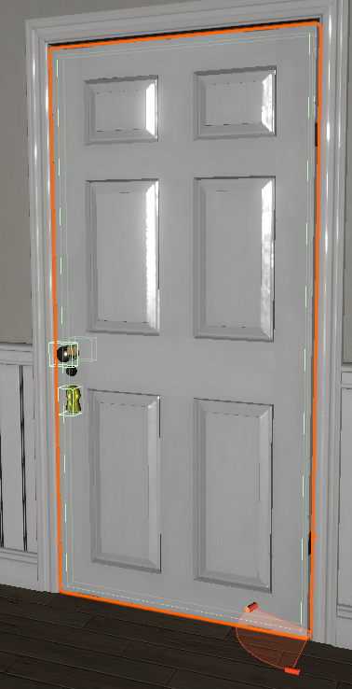There is another side to VR development that I haven’t talked about. Developing VR experience features can have unintended difficulties. Take a door for instance, in a typical 3d experience or game, a door can be opened by pressing a key. This would trigger an animation of the door opening. In VR, the door must be opened by the player, or else what’s the point of using VR? This example comes from a challenge that presented itself in the development, as the doors in Out of Sight, and the cupboards and the drawers, are all physically simulated. The door has rigidbody physics and is anchored to the world using a hinge. A door handle also had to be created that the player could pull on to open the door. Key and lock functionality was also adapted from the XR Interaction Toolkit. Getting the doors to open and close, lock and unlock and not break when you incorrectly interacted with was a challenge, and it took weeks to get right. This was due to Unity’s physics engine being temperamental and tricky to work with. There were many challenges like this, like levers being pulled could crash the game. This two-sided part of development where the interaction and systems were implemented was a slow and frustrating process as it always is, however as I have learnt VR development over the past few years, I can recognise that VR development is becoming easier and easier with every month, and these challenges could be defined as VR developments growing pains.

Figure 15 A VR interactable door with keyhole, Hinge and Doorhandle visible

## Experience Development

One of the positives to using Unity for Out of Sight was that once the VR development was mostly out of the way, the rest of the experience could be developed as normal. For instance, once things like doors and teleport enabled flooring had been set up, they could be copied and pasted around the scene as you would outside of VR development. Designing the levels for VR was simple because of this, as I could place objects in the world as normal, but if I used the VR headset, everything worked as expected. There are similarities and differences between non-VR and VR level design, one thing they have in-common is the use of soft-touch guiding, a technique I mentioned earlier by Mark Tempini. This is shown in Out of Sight in multiple ways, whether it’s the little table in the middle of the maze level that hints that the player is on the correct path, or whether it’s the childish giggles directing the player towards the first clue towards the end of the experience. Guiding with a soft touch in VR is an important tool. Many non-VR 3D experiences have a user interface, such as a small map or floating markers to identify the goal. UI isn’t a staple feature of VR, simply because we don’t have a heads-up display in the real-world, so why would we in a virtual world? This problem/feature is spread across VR experiences. Typically, settings in VR games are adjusted with physical buttons and levers, as again, in the real world there are no menus, so why would there be in VR? A great example of this is the small multiplayer game Gorilla Tag by Another Axiom (2021). In Gorilla Tag, you are a gorilla. You leave your tree and play tag with other gorillas, however if you want to be a blue gorilla, you climb up your tree and press big buttons on a big keyboard in the tree that changes settings. No menu is open, and the adjustable settings are canonically built into the experience.

Guiding with a soft touch alone can cause issues. Kanamgotov (2015) reported that several participants in their study found that the ‘system’ did not give them hints when they may have been helpful. Traditional video games and virtual experiences can give hints to the players and users often by throwing up dialogue on the screen or having a cut away scene to demonstrate what it being hinted. Virtual Reality can struggle with this, as you usually don’t want to pull people from the immersion by displaying information in an unnatural way. To combat this issue, Out of Sight has very linear gameplay, with additional narrative branches scattered around for users to explore. This design choice means users don’t necessarily need on-boarding as teleportation and grabbing objects is all that must be learned. Some of Kanamgotovs participants also mentioned scale as a limiting factor of immersion in virtual reality, which is a concerning factor when you are making a short linear experience. To help with this feeling, a whole level was designed in the experience based on long hallways and winding mazes. This allows the player to get lost and find the way following all the soft guided landmarks placed around the level. This level was designed with liminal space as its inspiration, as the level is set as a dream space in the experience. A liminal space is a concept described by Thomas (2021) as a space that is transitional and transformative, or “waiting areas between one point in time and space and the next”. Examples of Liminal Spaces are empty art galleries, abandoned shopping malls and long hotel hallways at night. These spaces lead to a phenomenon that often makes people feel unsettled, which is a perfect theme for surrealist horror. Designing virtual liminal spaces, especially long hallways, is something I have experience in VR, so it was straight forward for me to design the level.

The narrative for Out of Sight had to be subtle to intrigue the players and surprising when additional narrative is revealed through exploration. The narrative also had to be unsettling, hitting on uncomfortable themes and ending in a surreal experience. The narrative was designed in collaboration with Harri Bettsworth, as both the VR experience and the audio had to represent the same narrative, with sections such as the ‘Mother’ level, where a lullaby composed by Harri plays from a baby’s cot that was placed and animated by myself. A lot of the storyline for Out of Sight is up to user interpretation and for the user to solve. An example of this is the numerous children’s drawings around the experience that don’t line up with the environment. A lot of these drawings suggest that a second child lives in the home, however combined with the dialogue from the narrative, the player can work out that the second child is a paranormal entity. Its this method of finding clues and listening to various character dialogues throughout the experience that enable the player to piece together the adaptive narrative, and if done successfully, enable the player to experience an unsettling ending with answers to the plot.

# Conclusion

Out of Sight is an experience that uses Virtual Reality and Virtual Reality environment design to effectively enhance the immersion and engagement of an audience member experiencing a surreal horror audio experience. The VR aspect of Out of Sight builds upon emotions that audio alone may struggle to replicate, and in combination, the composition and design of the Out of Sight story world and sound design create an immersive and unsettling explicit branching narrative that can be uniquely experienced by the users. The initial goal to see if and how Virtual Reality can foster Horror experiences and engaging sound design has been met, as the project shows that VR adds many difficulties to development, but the effect it has when done right is unmatchable by any other medium, as the player gets to live in the experience and not just interact with it from an external perspective.

The project wasn’t without its technical and personal challenges, especially with VR development. The additional development time required with VR is a hurdle, as it made it difficult to keep up with the progress that was being made with the narrative and sound design, and this in turn made it personally difficult to motivate myself, as the development had many long days and weeks of bug fixing and stress causing issues. However, the process has in-turn taught me a lot about VR development and optimisation that in the future will reduce the size of the VR development hurdle, whilst the evolving technology does the same. My creative process for developing VR experiences has been built upon, with design techniques created and learnt through this project that will follow me to all future VR projects.

Out of Sight is an example of how VR can improve a narrative experience, and how VR is a great platform for experiencing audio pieces, as a genuine 3D environment that can be explored with no limitations creates an immersive environment for the audio to accentuate itself with. Directionality, occlusion and spatialization are powerful tools to make the sound design experiential, and VR takes the most from these tools. Other experiences could learn a lot from Out of Sight, as it is clear from this project that not only is VR a great tool for audio experiences, but also that spatialized and adaptive audio is great for fully immersing one of the senses that VR hardware alone does not. Looking into the future of my own personal VR development, I will find it difficult not to use FMOD with spatialized audio for everything, as it makes the experience and environment feel that more real.

With hindsight, many things could have been different in Out of Sight. I would have loved for more interaction and narrative within the experience, bringing it closer to a game more than an experience, however this was not the main goal of the practice-based research project. Plus, many of the limitations I experienced in Out of Sight was due to the time it took to develop technical systems that wouldn’t take anywhere near as long if I were to repeat the project.

I believe that both Out of Sight, and this commentary discussing the project, show that Virtual Reality is a powerful tool for developing effective experiences. Together with Harri Bettsworth, I created an experience that met all our initial goals for immersion and feeling, with the quality of the virtual environment and the quality of the composed audio complimenting one another.

# References

ANOTHER AXIOM. (2021) *Gorilla Tag*. Another Axiom

ANTONIADES, T. (2017) *Hellblade: Senua's Sacrifice*. Cambridge, UK: Ninja Theory

AUDIOKINETIC INC. (2021) *Wwise | Audiokinetic*. [Online] Available from: https://www.audiokinetic.com/products/wwise/

BEACHUM, A. (2019) *The Outer Wilds*. Los Angeles, California: Mobius Digital

BERGER, C. et al. (2018) *Generic HRTFs May be Good Enough in Virtual Reality. Improving Source Localization through Cross-Modal Plasticity*. Frontiers in Neuroscience Vol. 12

BROWN, E. and CAIRNS, P. (2004) *‘A Grounded Investigation of Game Immersion’*. CHI‘04 Extended Abstracts on Human Factors and Computing Systems (Vienna, April 2004), ACM Press, pp. 1297–1300.

*Eraserhead*. (1977) [film] Dir. by DAVID LYNCH.Center for Advanced Film Studies, American Film Institute: American Film Institute

FELTHAM, J. (2021) *Half-Life: Alyx Is VR's Best Game, Not Its Most Innovative*. [Online] Available from: <https://uploadvr.com/half-life-alyx-editorial-one-year/>

GITHUB. (2021) *GitHub: Where the world builds software*. [Online] Available from: <https://github.com/>

HAYDEN, S., 2021. 'Rec Room' Studio Estimates Facebook Sold 2-3M Oculus Quest 2 Headsets in Q4. [online] Road to VR. Available at: <https://www.roadtovr.com/facebook-rec-room-2-3m-oculus-quest-2-sold/>.

HILLS-DUTY, R. (2018) *Review: Resident Evil VII biohazard*. [Online] Available from: <https://www.vrfocus.com/2018/11/review-resident-evil-vii-biohazard/>

KANAMGOTOV, A., 2015. *A framework for immersion in virtual reality*. Ph.D. University of Bedfordshire.

KOJIMA, H. (2014) *P.T.*. Japan: Konami

LANG, B. (2021) *Oculus is "All in on OpenXR," New Developer Features Will Come to OpenXR Only*. [Online] Available from: https://www.roadtovr.com/oculus-openxr-shift-unity-unreal-engine/

LINDLEY, C. (2008) Story and Narrative Structures in Computer Games. Available from <https://citeseerx.ist.psu.edu/viewdoc/summary?doi=10.1.1.119.797>

PLUTCHIK, R. (1988) The Nature of Emotions: Clinical Implications. Available from https://link.springer.com/chapter/10.1007%2F978-1-4757-1987-1_1

*The Shining*. (1980) [film] Dir. by STANLEY KUBRICK. Elstree Studios, Ltd., Borehamwood, England: Stanley Kubrick

TEMPINI, M., 2019. *Guiding with a Soft Touch: Directing Players in Nonlinear Levels Without UI*. Press Start, 5(2).

TSUBOYAMA, M. (2001) *Silent Hill 2*. Tokyo: Konami Computer Entertainment Tokyo

STEAM AUDIO (2017) Bilinear HRTF Interpolation in Steam Audio. [weblog] *Steam Community*. Available from: <https://steamcommunity.com/games/596420/announcements/detail/507059261126291719>

STEAM AUDIO (2021) *Steam Audio FMOD Studio Integration documentation*. [Online] Available from: <https://valvesoftware.github.io/steam-audio/doc/fmod/>

# Appendices

Appendix A: Build loader. A C# script for ensuring the right scene loads first when built.

using UnityEngine;

using UnityEngine.SceneManagement;

public class BuildLoader : MonoBehaviour

{

[Tooltip("The first scene to load when the application is loaded outside of the editor. This ensures the Persistent scene loads first.")]

public string startScene = "Intro"; //The first scene to load when the application is loaded outside of the editor. This ensures the Persistent scene loads first.

// Start is called before the first frame update

void Awake()

{

if (!Application.isEditor)

SceneManager.LoadSceneAsync(startScene, LoadSceneMode.Additive);

}

}

Appendix B: A system for loading scenes without unloading the persistent scene that houses the VR functionality.

using System.Collections;

using System.Collections.Generic;

using UnityEngine;

using TMPro;

using UnityEngine.Events;

using UnityEngine.SceneManagement;

using UnityEngine.XR.Interaction.Toolkit;

public class SceneLoader : Singleton<SceneLoader>

{

public GameObject xrinteractionManagerObject;

private XRInteractionManager xrinteractionManager;

public XRBaseInteractor[] interactors;

public UnityEvent OnLoadBegin = new UnityEvent();

public UnityEvent OnLoadEnd = new UnityEvent();

public ScreenFader screenFader = null;

private bool isLoading = false;

[Tooltip("Adds an additional delay to the loading coroutines to test on fast loading scenes.")]

public bool debugTime = false;

private void Awake()

{

SceneManager.sceneLoaded += SetActiveScene; // Attaches the set active scene function to the SceneManager.sceneLoaded action

xrinteractionManager = xrinteractionManagerObject.GetComponent<XRInteractionManager>();

}

private void OnDestroy()

{

SceneManager.sceneLoaded -= SetActiveScene; // Detatches the set active scene function

}

public void LoadNewScene(string sceneName)

{

if (!isLoading)

StartCoroutine(LoadScene(sceneName, false));

}

public void LoadNewSceneInstant(string sceneName)

{

if (!isLoading)

StartCoroutine(LoadScene(sceneName, true));

}

private IEnumerator LoadScene(string sceneName, bool instant)

{

isLoading = true; // Loading start

// Unloads current scene, fades screen and triggers OnLoadBegin event

OnLoadBegin?.Invoke();

if (instant)

{

float duration = screenFader.FadeInInstant();

yield return new WaitForSeconds(3f);

}

else

{

float duration = screenFader.FadeIn();

yield return new WaitForSeconds(duration+2f);

}

yield return new WaitForEndOfFrame();

yield return StartCoroutine(UnloadCurrent());

if (debugTime) // Adds debug delay

yield return new WaitForSeconds(8.0f);

//xrinteractionManager = xrinteractionManagerObject.AddComponent<XRInteractionManager>() as XRInteractionManager;

//foreach (var item in interactors)

//{

// item.interactionManager = xrinteractionManager;

//}

// Loads new scene, unfades screen and triggers OnLoadEnd event

yield return StartCoroutine(LoadNew(sceneName));

OnLoadEnd?.Invoke();

isLoading = false; // Loading end

yield return null;

}

private IEnumerator UnloadCurrent()

{

//Destroy(xrinteractionManager);

AsyncOperation unloadOperation = SceneManager.UnloadSceneAsync(SceneManager.GetActiveScene());

while (!unloadOperation.isDone)

{

yield return null;

}

}

private IEnumerator LoadNew(string sceneName)

{

AsyncOperation loadOperation = SceneManager.LoadSceneAsync(sceneName, LoadSceneMode.Additive);

loadOperation.allowSceneActivation = false;

while (!loadOperation.isDone)

{

// Output the current progress

//loadingText.text = "Loading progress: " + (loadOperation.progress * 100) + "%";

// Check if the load has finished

if (loadOperation.progress >= 0.9f)

{

loadOperation.allowSceneActivation = true;

yield return null;

}

}

}

private void SetActiveScene(Scene scene, LoadSceneMode mode)

{

IEnumerator coroutine = SetActiveSceneCoroutine(scene, mode);

StartCoroutine(coroutine);

}

private IEnumerator SetActiveSceneCoroutine(Scene scene, LoadSceneMode mode)

{

yield return new WaitForEndOfFrame();

SceneManager.SetActiveScene(scene);

screenFader.FadeOut();;

}

}

Appendix C: A class for inheriting from. Uses the Singleton pattern to ensure that anything that inherits from this class can only exist once. For use with system functionality.

using System.Collections;

using System.Collections.Generic;

using UnityEngine;

public class Singleton<T> : MonoBehaviour where T : MonoBehaviour

{

public static T instance = null;

public static T Instance

{

get

{

if((object)instance == null)

{

instance = (T)FindObjectOfType(typeof(T));

if (instance == null)

{

GameObject singletonObject = new GameObject(typeof(T).ToString());

instance = singletonObject.AddComponent<T>();

}

}

return instance;

}

}

}

Appendix D: A class to expose functionality of the inbuilt XR Interaction Manager. Was created to fix a bug in the XR Interaction Toolkit.

using UnityEngine;

using UnityEngine.XR.Interaction.Toolkit;

using System.Reflection;

public class XRInteractionManagerExposed : MonoBehaviour

{

private static XRInteractionManagerExposed instance = null;

private XRInteractionManager manager = null;

private MethodInfo unregisterInteractable = null;

public static XRInteractionManagerExposed GetInstance()

{

return instance;

}

private void Start()

{

instance = this;

manager = this.GetComponent<XRInteractionManager>();

System.Type t = typeof(XRInteractionManager);

MethodInfo[] methods = t.GetMethods(BindingFlags.NonPublic | BindingFlags.Instance);

foreach (MethodInfo mi in methods)

{

if (mi.Name == "UnregisterInteractable")

{

unregisterInteractable = mi;

break; //leave the loop

}

}

}

public void UnregisterInteractable(XRBaseInteractable interactable)

{

object[] args = new Object[] { interactable };

unregisterInteractable.Invoke(manager, args);

}

}

Appendix E: A similar system to Appendix D. Created to rectify an in-built bug

using System.Collections;

using System.Collections.Generic;

using UnityEngine;

using UnityEngine.XR.Interaction.Toolkit;

public class UnregisterInteractor : MonoBehaviour

{

//This script attempts to unregister the xrgrabinteractable before it is deleted via scene loading. This is due to a XR Interaction Manager bug that crashes the manager when a interactable is deleted whilst an interactor is within its collider.

public XRBaseInteractable xrBaseInteractable;

public void Unregister()

{

if (xrBaseInteractable != null) xrBaseInteractable.colliders.Clear();

else Debug.LogError("UnregisterInteractor scipt missing reference to xrBaseInteractable on " + this.transform.name);

}

}

Appendix F: A custom class for teleportation areas, built from the existing teleport area code from the XR Interaction Toolkit.

using System.Collections;

using System.Collections.Generic;

using UnityEngine;

using UnityEngine.Events;

using UnityEngine.XR.Interaction.Toolkit;

public class TeleportAreaFade : TeleportationArea

{

public ScreenFader screenFade = null;

protected override void OnSelectEnter(XRBaseInteractor interactor)

{

if (teleportTrigger == TeleportTrigger.OnSelectEnter)

SendTeleportRequest(interactor, base.onSelectEnter);

}

protected override void OnSelectExit(XRBaseInteractor interactor)

{

if (teleportTrigger == TeleportTrigger.OnSelectExit)

SendTeleportRequest(interactor, base.onSelectExit);

}

protected override void OnActivate(XRBaseInteractor interactor)

{

if (teleportTrigger == TeleportTrigger.OnActivate)

SendTeleportRequest(interactor, base.onActivate); ;

}

protected override void OnDeactivate(XRBaseInteractor interactor)

{

if (teleportTrigger == TeleportTrigger.OnDeactivate)

SendTeleportRequest(interactor, base.onDeactivate);

}

private IEnumerator FadeSequence(UnityEvent<XRBaseInteractor> actionEvent, XRBaseInteractor interactor, RaycastHit raycastHit, TeleportRequest tr)

{

float duration = screenFade.duration;

yield return new WaitForSeconds(screenFade.FadeIn());

if (GenerateTeleportRequest(interactor, raycastHit, ref tr))

{

m_TeleportationProvider.QueueTeleportRequest(tr);

}

actionEvent.Invoke(interactor);

screenFade.FadeOut();

}

private void OnValidate()

{

if (!screenFade)

screenFade = FindObjectOfType<ScreenFader>();

}

void SendTeleportRequest(XRBaseInteractor interactor, UnityEvent<XRBaseInteractor> actionEvent)

{

if (!interactor || m_TeleportationProvider == null)

return;

XRRayInteractor rayInt = interactor as XRRayInteractor;

if (rayInt != null)

{

RaycastHit raycastHit;

if (rayInt.GetCurrentRaycastHit(out raycastHit))

{

// are we still selecting this object

bool found = false;

for (int i = 0; i < colliders.Count; i++)

{

if (colliders[i] == raycastHit.collider)

{

found = true;

break;

}

}

if (found)

{

TeleportRequest tr = new TeleportRequest();

tr.matchOrientation = m_MatchOrientation;

tr.requestTime = Time.time;

StartCoroutine(FadeSequence(actionEvent, interactor, raycastHit, tr));

}

}

}

}

}

Appendix G: A custom class for handling initial teleport requests to ensure the player loads into the correct location. Was unused due to an other system replicating its functionality, however the spawn point was used extensively in testing as it could be easily moved around.

using System;

using UnityEngine;

namespace UnityEngine.XR.Interaction.Toolkit

{

public class SpawnPoint : BaseTeleportationInteractable

{

[SerializeField]

[Tooltip("The transform that represents the teleportation destination")]

Transform m_TeleportAnchorTransform;

/// <summary>

/// The transform that represents the teleportation destination

/// </summary>

public Transform teleportAnchorTransform { get { return m_TeleportAnchorTransform; } set { m_TeleportAnchorTransform = value; } }

[SerializeField] protected bool isSpawnPoint = false;

private void OnValidate()

{

if (teleportAnchorTransform == null)

teleportAnchorTransform = transform;

}

private void Start()

{

if(isSpawnPoint)

{

TeleportRequest teleportRequest = new TeleportRequest();

teleportRequest.matchOrientation = m_MatchOrientation;

teleportRequest.requestTime = Time.time;

if (teleportAnchorTransform != null)

{

teleportRequest.destinationPosition = m_TeleportAnchorTransform.position;

teleportRequest.destinationUpVector = m_TeleportAnchorTransform.up;

teleportRequest.destinationRotation = m_TeleportAnchorTransform.rotation;

teleportRequest.destinationForwardVector = m_TeleportAnchorTransform.forward;

m_TeleportationProvider.QueueTeleportRequest(teleportRequest);

}

}

}

protected override bool GenerateTeleportRequest(XRBaseInteractor interactor, RaycastHit raycastHit, ref TeleportRequest teleportRequest)

{

if (teleportAnchorTransform == null)

{

return false;

}

teleportRequest.destinationPosition = m_TeleportAnchorTransform.position;

teleportRequest.destinationUpVector = m_TeleportAnchorTransform.up;

teleportRequest.destinationRotation = m_TeleportAnchorTransform.rotation;

teleportRequest.destinationForwardVector = m_TeleportAnchorTransform.forward;

return true;

}

private void OnDrawGizmos()

{

Gizmos.color = Color.blue;

GizmoHelpers.DrawWireCubeOriented(m_TeleportAnchorTransform.position, m_TeleportAnchorTransform.rotation, 1.0f);

GizmoHelpers.DrawAxisArrows(m_TeleportAnchorTransform, 1.0f);

}

}

}

Appendix H: A system for resetting the headset tracking wherever necessary. Unused by the Quest 2 headset but there to accommodate all VR headsets that are compatible.

using System.Collections;

using System.Collections.Generic;

using UnityEngine;

using UnityEngine.XR;

public class resetTrackedPoseDriver : MonoBehaviour

{

// Start is called before the first frame update

void Start()

{

List<InputDevice> devices = new List<InputDevice>();

InputDevices.GetDevices(devices);

if (devices.Count != 0)

{

devices[0].subsystem.TryRecenter();

}

}

}

Appendix I: A static class for handling gameplay data between levels.

using System.Collections;

using System.Collections.Generic;

using UnityEngine;

public class GameData : Singleton<GameData>

{

[SerializeField] private short level = 0;

[SerializeField] private short fearLevel = 0;

public short Level

{

get { return level; }

set { level = value; }

}

public short LevelUp()

{

level++;

return level;

}

public short FearLevel

{

get { return fearLevel; }

set { fearLevel = value; }

}

public short FearLevelUp()

{

fearLevel++;

return fearLevel;

}

}

Appendix J: A shader for fading the screen, and the code to use it

Shader "Custom/Fader"

{

Properties

{

_FadeColor("FadeColor", Color) = (1, 1, 1)

_Alpha("Alpha", float) = 0.0

}

SubShader

{

Cull Off ZWrite Off ZTest Always

Blend SrcAlpha OneMinusSrcAlpha

Pass

{

CGPROGRAM

#pragma vertex vert

#pragma fragment frag

#include "UnityCG.cginc"

struct appdata

{

float4 vertex : POSITION;

float2 uv : TEXCOORD0;

};

struct v2f

{

float2 uv : TEXCOORD0;

float4 vertex : SV_POSITION;

};

v2f vert(appdata v)

{

v2f o;

o.vertex = UnityObjectToClipPos(v.vertex);

o.uv = v.uv;

return o;

}

fixed4 _FadeColor;

half _Alpha;

fixed4 frag(v2f i) : SV_Target

{

fixed4 color = fixed4(_FadeColor.rgb, _Alpha);

return color;

}

ENDCG

}

}

}

using System.Collections;

using UnityEngine;

using UnityEngine.Rendering.Universal;

//Needs updating to URP

public class ScreenFader : MonoBehaviour

{

public ForwardRendererData rendererData = null;

[Range(0, 1)] public float alpha = 0.0f;

[Range(0, 5)] public float duration = 0.5f;

private Material fadeMaterial = null;

private void Start()

{

SetupFadeFeature();

}

private void SetupFadeFeature()

{

ScriptableRendererFeature feature = rendererData.rendererFeatures.Find(item => item is ScreenFadeFeature);

if (feature is ScreenFadeFeature screenFade)

{

fadeMaterial = Instantiate(screenFade.settings.material);

screenFade.settings.runTimeMaterial = fadeMaterial;

}

FadeOut();

}

public float FadeIn()

{

StartCoroutine(LerpMaterialAlpha(0f, 1f));

return duration;

}

public float FadeOut()

{

StartCoroutine(LerpMaterialAlpha(1f, 0f));

return duration;

}

public float FadeInInstant()

{

fadeMaterial.SetFloat("_Alpha", 1.0f);

return duration;

}

public float FadeOutInstant()

{

fadeMaterial.SetFloat("_Alpha", 0.0f);

return duration;

}

IEnumerator LerpMaterialAlpha(float startValue, float endValue)

{

float timeElapsed = 0;

while (timeElapsed < duration)

{

alpha = Mathf.Lerp(startValue, endValue, timeElapsed / duration);

timeElapsed += Time.deltaTime;

fadeMaterial.SetFloat("_Alpha", alpha);

yield return null;

}

alpha = endValue;

fadeMaterial.SetFloat("_Alpha", alpha);

}

}

using UnityEngine.Rendering;

using UnityEngine.Rendering.Universal;

public class ScreenFadePass : ScriptableRenderPass

{

private ScreenFadeFeature.FadeSettings settings = null;

public ScreenFadePass(ScreenFadeFeature.FadeSettings newSettings)

{

settings = newSettings;

renderPassEvent = newSettings.renderPassEvent;

}

public override void Execute(ScriptableRenderContext context, ref RenderingData renderingData)

{

//Set command to store instructions

CommandBuffer command = CommandBufferPool.Get(settings.profilerTag);

// Get the location of our textures

RenderTargetIdentifier source = BuiltinRenderTextureType.CameraTarget;

RenderTargetIdentifier destination = BuiltinRenderTextureType.CurrentActive;

// Copy texture info with added material

command.Blit(source, destination, settings.runTimeMaterial);

context.ExecuteCommandBuffer(command);

// Release command

CommandBufferPool.Release(command);

}

}

using System;

using UnityEngine;

using UnityEngine.Rendering.Universal;

public class ScreenFadeFeature : ScriptableRendererFeature

{

public FadeSettings settings = null;

private ScreenFadePass renderPass = null;

public override void Create()

{

// create a new pass using these settings

renderPass = new ScreenFadePass(settings);

}

public override void AddRenderPasses(ScriptableRenderer renderer, ref RenderingData renderingData)

{

// Add the pass

if (settings.AreValid())

renderer.EnqueuePass(renderPass);

}

[Serializable]

public class FadeSettings

{

public bool isEnabled = true;

public string profilerTag = "Screen Fade";

public RenderPassEvent renderPassEvent = RenderPassEvent.AfterRenderingPostProcessing;

public Material material = null;

[NonSerialized] public Material runTimeMaterial = null;

public bool AreValid()

{

return ((runTimeMaterial != null) && isEnabled);

}

}

}

Appendix K: A class for controlling the end scenes so they are adaptable.

using System.Collections;

using System.Collections.Generic;

using UnityEngine;

using UnityEngine.XR;

using UnityEngine.SceneManagement;

using FMODUnity;

public class endmanager : MonoBehaviour

{

public GameObject end1;

public GameObject end2;

public int FearRequirement = 3;

bool fullEnding = false;

Transform trackedPose;

public Transform sceneObject;

public string nextScene = "Intro";

bool isPlaying = false;

public bool skipCredits = false;

// Start is called before the first frame update

void Start()

{

if (GameData.Instance.FearLevel >= FearRequirement)

{

end1.SetActive(false);

end2.SetActive(true);

}

else

{

end1.SetActive(true);

end2.SetActive(false);

}

trackedPose = GameObject.Find("TrackedPoseDriver").transform;

StartCoroutine(LateStart(1.0f));

}

IEnumerator LateStart(float waitTime)

{

yield return new WaitForSeconds(waitTime);

Vector3 pos = sceneObject.position + trackedPose.position;

pos.y = Camera.main.transform.position.y - 0.45f;

sceneObject.position = pos;

if (skipCredits)

{

yield return new WaitForSeconds(4.0f);

SceneLoader.Instance.LoadNewScene(nextScene);

}

}

}

Appendix L: A class for bugged items that get out of reach. Returns them to the original position.

using System.Collections;

using System.Collections.Generic;

using UnityEngine;

public class ResetPosition : MonoBehaviour

{

private Vector3 pos;

private Quaternion rot;

private Rigidbody rb = null;

// Start is called before the first frame update

void Start()

{

if (!gameObject.GetComponent<Rigidbody>()) rb = null;

pos = transform.position;

rot = transform.rotation;

}

public void resetPosition()

{

transform.position = pos;

transform.rotation = rot;

if (rb != null)

{

rb.velocity = Vector3.zero;

rb.angularVelocity = Vector3.zero;

}

}

}

Appendix M: A class to scroll through text in the intro and end scenes.

using System.Collections;

using System.Collections.Generic;

using UnityEngine;

using TMPro;

[RequireComponent(typeof(TMPro.TMP_Text))]

public class TextScroller : MonoBehaviour

{

[Range(0f, 10f)] [Tooltip("Amount of time for text to fade out")] public float fadeOutTime; //Amount of time for text to fade out

[Range(0f, 10f)] [Tooltip("Amount of time for text to fade in")] public float fadeInTime; //Amount of time for text to fade in

[Range(0f, 100f)] [Tooltip("Amount of time that the text stays visible")] public float staticTime; //Amount of time that the text stays visible

[Range(0f, 100f)] [Tooltip("Amount of time that the text stays hidden")] public float breakTime; //Amount of time that the text stays hidden

[Space]

[Tooltip("The array of strings for the Text Scroller to scroll through")] public string[] texts; //The array of strings for the Text Scroller to scroll through

TMP_Text textField;

int counter = 0;

bool showing = true;

float t1 = 0f;

float t2 = 0f;

// Start is called before the first frame update

void Start()

{

textField = GetComponent<TMP_Text>();

textField.text = texts[counter];

counter++;

StartCoroutine("Wait");

}

// Update is called once per frame

void Update()

{

t1 += Time.deltaTime / (fadeOutTime*100);

t2 += Time.deltaTime / (fadeInTime*100);

if (!showing) textField.color = new Color(textField.color.r, textField.color.g, textField.color.b, Mathf.Lerp(textField.color.a, 0f, t1));

if (showing) textField.color = new Color(textField.color.r, textField.color.g, textField.color.b, Mathf.Lerp(textField.color.a, 255f, t2));

}

IEnumerator Wait()

{

while (true)

{

if (showing) yield return new WaitForSeconds(staticTime+fadeInTime);

if (!showing) yield return new WaitForSeconds(breakTime+fadeOutTime);

if (!showing)

{

if (counter >= texts.Length) counter = 0;

textField.text = texts[counter];

counter++;

}

showing = !showing;

t1 = 0f; t2 = 0f;

}

}

}

Appendix N: A script to control images that fade via animation

using System.Collections;

using System.Collections.Generic;

using UnityEngine;

public class PictureFade : MonoBehaviour

{

[SerializeField] private Animator myAnimator;

public bool isVisible = false;

public FMODUnity.StudioEventEmitter em;

// Start is called before the first frame update

void Start()

{

// If there is no animator in the gameobject itself, get the parent animator.

myAnimator = GetComponent<Animator>();

if (myAnimator == null)

{

myAnimator = GetComponentInParent<Animator>();

}

if (isVisible)

{

myAnimator.Play("PictureFadeIn");

em.Play();

}

else

{

myAnimator.Play("PictureFadeOut");

}

}

public void Fade(bool IO)

{

if(IO)

{

myAnimator.Play("PictureFadeIn");

}

else

{

myAnimator.Play("PictureFadeOut");

}

}

}

Appendix O: A class created for simple audio implementation, allows simple triggers to effect complex events.

using System.Collections;

using System.Collections.Generic;

using UnityEngine;

using UnityEngine.Events;

public class OnTrigger : MonoBehaviour

{

[Tooltip("The collider tag that will trigger the event.")]

public string ColliderTag = "Player";

[Tooltip("Calls when trigger is entered.")]

public UnityEvent Enter;

[Tooltip("Calls when trigger is exitted.")]

public UnityEvent Exit;

private void Start()

{

if (Enter == null)

Enter = new UnityEvent();

if (Exit == null)

Exit = new UnityEvent();

}

private void OnTriggerEnter(Collider other)

{

if(other.tag == ColliderTag) Enter.Invoke();

}

private void OnTriggerExit(Collider other)

{

if (other.tag == ColliderTag) Exit.Invoke();

}

}

Appendix P: The class for adapting the house environment as the narrative progresses.

using System.Collections;

using System.Collections.Generic;

using UnityEngine;

public class HouseSetup : MonoBehaviour

{

[SerializeField] private GameObject xrRig;

[SerializeField] private GameObject[] levelObjects;

[SerializeField] private Vector3[] levelPositions;

private short levelVal = 0;

// Start is called before the first frame update

void Start()

{

xrRig = GameObject.Find("XR Rig");

levelVal = GameData.Instance.Level;

switch (levelVal)

{

default:

Debug.LogError("FATAL: HouseSetup.cs Line 19 - levelVal (called from GameData singleton) value exceeds expected range");

break;

case 0:

foreach (var lvlobj in levelObjects)

{

lvlobj.SetActive(false);

}

levelObjects[0].SetActive(true);

xrRig.transform.position = levelPositions[0];

break;

case 1:

foreach (var lvlobj in levelObjects)

{

lvlobj.SetActive(false);

}

levelObjects[1].SetActive(true);

xrRig.transform.position = levelPositions[1];

break;

case 2:

foreach (var lvlobj in levelObjects)

{

lvlobj.SetActive(false);

}

levelObjects[2].SetActive(true);

xrRig.transform.position = levelPositions[2];

break;

}

}

public void IncrementGameLevel()

{

GameData.Instance.LevelUp();

}

public void IncrementFearLevel()

{

GameData.Instance.FearLevelUp();

}

public int ReturnGameLevel()

{

return GameData.Instance.Level;

}

public int ReturnFearLevel()

{

return GameData.Instance.FearLevel;

}

}

Appendix Q: Script for handling doors.

using System.Collections;

using System.Collections.Generic;

using UnityEngine;

public class DoorHandler : MonoBehaviour

{

public Transform Handler;

private Rigidbody rb;

public void ResetPosition()

{

GetComponent<Rigidbody>().velocity = Vector3.zero;

GetComponent<Rigidbody>().angularVelocity = Vector3.zero;

this.transform.SetPositionAndRotation(Handler.position, Handler.rotation);

}

}

Appendix R: Script for adding force to physics objects.

using System.Collections;

using System.Collections.Generic;

using UnityEngine;

public class AddForce : MonoBehaviour

{

[SerializeField] Transform forceposition;

[SerializeField] bool isExplosion = false;

[SerializeField] float explosionRadius = 0.5f;

[SerializeField] float Force = 200f;

Rigidbody rb;

[SerializeField] bool trigger = false;

[SerializeField] bool stopSleeping = true;

private void Start()

{

rb = GetComponent<Rigidbody>();

if(stopSleeping) rb.sleepThreshold = 0.001f;

}

private void Update()

{

if (trigger) addForce();

trigger = false;

}

public void addForce()

{

if (isExplosion)

{

Collider[] colliders = Physics.OverlapSphere(forceposition.position, explosionRadius);

foreach (Collider hit in colliders)

{

Rigidbody rb1 = hit.GetComponent<Rigidbody>();

if (rb1 != null) rb1.AddExplosionForce(Force, forceposition.position, explosionRadius, 3.0F);

}

}

else

{

rb.AddForceAtPosition(((transform.position - forceposition.position) * Force), forceposition.position, ForceMode.Acceleration);

}

}

}

Appendix S: Bloody Cot 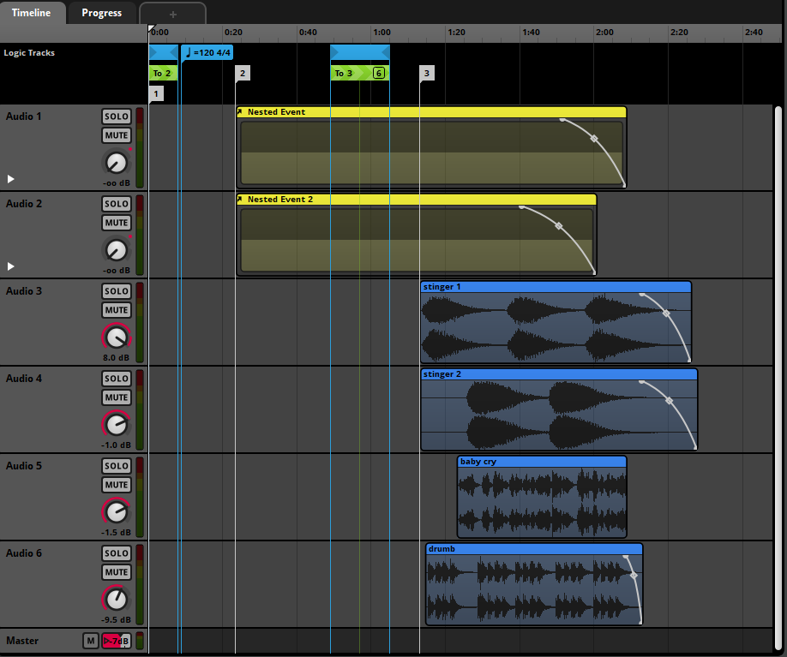Adaptive Piece

Appendix T: 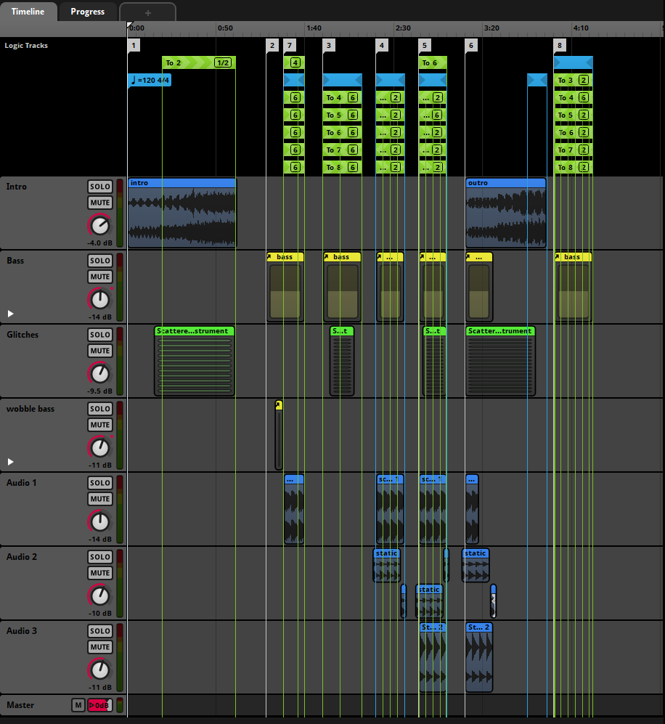Minimalist 1 Adaptive Piece

Appendix U: Minimalist 2 Adaptive Piece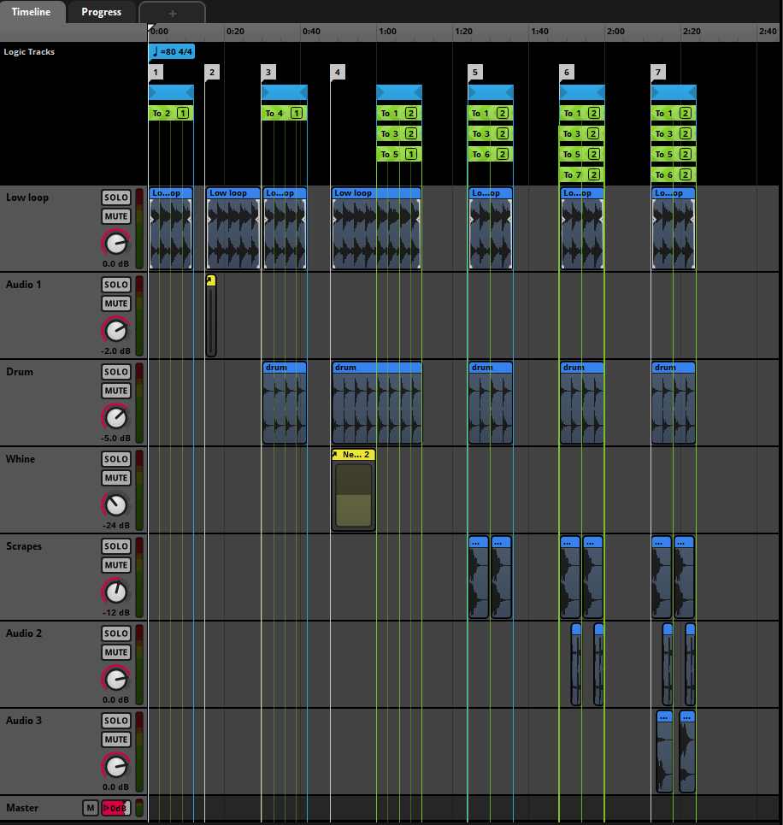

Appendix V: Maze Adaptive Piece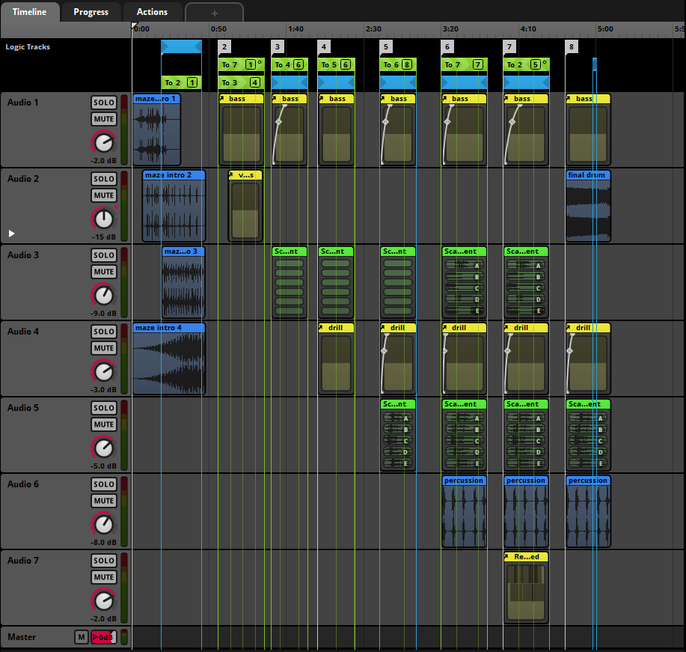

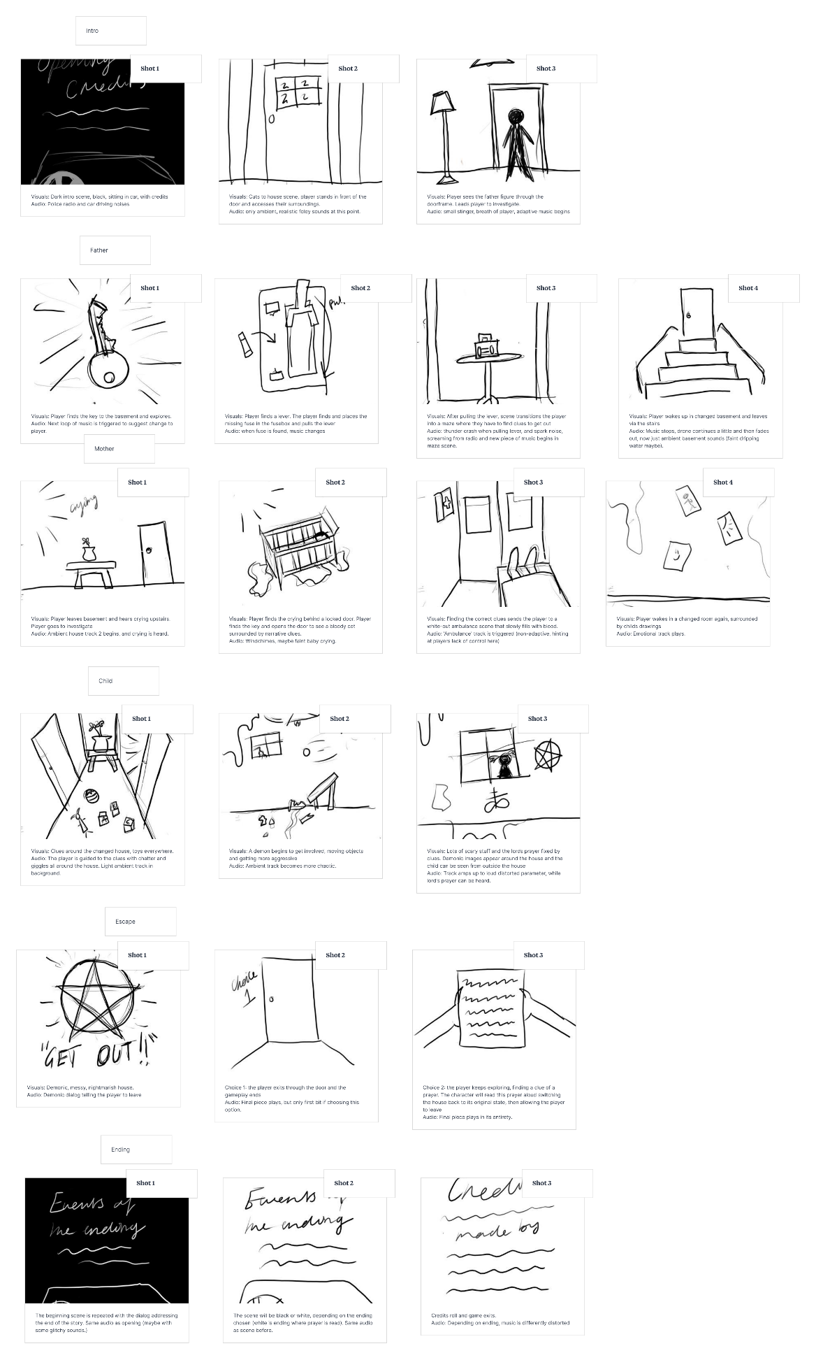Appendix W: Initial Storyboard plan.